DEVELOPING SHARED EDUCATION IN EARLY YEARS SETTINGS

A FRAMEWORK FOR COLLABORATIVE PARTNERSHIPS

2016 -2017

The Education and Training Inspectorate
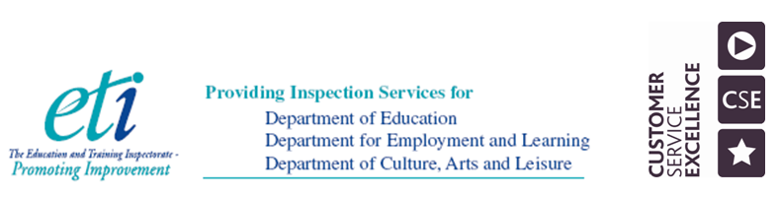
DEVELOPING SHARED EDUCATION
Introduction

Whilst our education system reflects historical divisions in society, the benefits of educating children and young people together are increasingly recognised. In recent years, the concept of Shared Education has developed to provide opportunities for children and young people from different community backgrounds to learn together. The pre-school expansion programme in 1998 was underpinned by the principles of ‘cross-community’ education and initial funding of settings was based on the protocol of provision for young children to learn together for one year. The voluntary sector expanded rapidly through the provision of cross-community pre-school playgroups and enhanced the established nursery schools and development of nursery units at primary schools.

Pre-school children are entitled to apply for a free place in a setting such as a:
- Nursery School
- Nursery Unit
- Playgroup
- Private Daycare
- Reception class or group( funded pre-school places in a small number of mostly small rural primary schools)

Settings in the voluntary sector are registered by and subject to annual inspection by the Department of Health and Social Services and Public Safety(DHSSPS) .
ETI inspect all settings based on the Pre-School Curricular Guidance and Quality Indicators.

The Curricular Guidance for Pre-School indicates that in promoting best practice to ensure equality of opportunity that:

“It is important that young children are helped to understand that we see the world in many different ways depending on our cultural, social and religious viewpoints. Staff in settings should acknowledge and respect the culture, beliefs and lifestyles of the families of all children. When planning, include activities and resources that encourage respect for diversity within our own society. Examples include talking about cultural and religious festivals, preparing foods from different countries, reading stories or listening to music from different cultures, and displaying photographs of cultural traditions”

In addition, section 75 is promoted by:

‘opportunities to explore situations, express feelings in a way that is not gender specific and to challenge stereotypes’ and ‘children with additional needs and those for whom English is not their first language have a right to equal access to all areas of learning so that their capabilities are fully developed.’

The DHSSPS has set minimum standards for the registration and inspection of voluntary playgroups and Standard 8 requires that:

“ the setting actively promotes equality of opportunity and inclusion for all children and their parents and staff and positively values diversity”

All settings must ensure:
- Admission of children to the setting and their access to itrs resources, activities and facilities is based on criteria which comply with equality legislation.
- All children, staff and adults are treated with equal worth, respect and value in compliance with relevant equality and anti-discrimination legislation.
- Equal opportunities are promoted with regard to employment and training of staff, trainees, students and volunteers.

Shared Education involves the provision of opportunities for children and young people from different community backgrounds to learn together for better education and reconciliation outcomes.

Shared Education is defined as the organisation and delivery of education so that it:

- meets the needs of, and provides for the education together of learners from all Section 75 categories and socio-economic status;
- involves schools and other education providers of differing ownership, sectoral identity and ethos, management type or governance arrangements; and
- delivers educational benefits to learners, promotes the efficient and effective use of resources, and promotes equality of opportunity, good relations, equality of identity, respect for diversity and community cohesion.

Specifically, Shared Education involves the provision of opportunities for children and young people from different community backgrounds to learn together.

The vision is for:
Vibrant, self-improving Shared Education partnerships delivering social change through educational benefits to pupils; promoting equality of opportunity, good relations, equality of identity, respect for diversity and community cohesion; and encouraging the efficient and effective use of resources.

Shared Education to date

Since the early 1980s, DE has developed and implemented a range of programmes to promote cross-community relations by bringing young people from each of the two main traditions together. The overarching aim was to improve mutual understanding and relationships between the two main traditions without excluding any other tradition. Many schools also developed their own working relationships with other schools from different backgrounds independently. In 2011, DE launched a new Community Relations, Equality and Diversity in Education (CRED) policy which encouraged schools and youth settings to work collaboratively.

In recent years, and with the support of external funding from the International Fund for Ireland and the Atlantic Philanthropies, the concept of a more strategic approach to Shared Education has evolved and a series of pilot projects were implemented.

Wider Context
Shared Education is developing within a wider legislative and policy context that is designed to promote equality and good relations.

“Building a Strong and Shared Community” has been recognised by the Northern Ireland Executive both as a key priority within its Programme for Government 2011-15 (PFG) and as essential to the growth of a strong, modern economy and society. The PfG sets out three specific objectives for the Department of Education relating to Shared Education:

- to establish a Ministerial Advisory Group to advise on advancing Shared Education;
- to ensure all children have the opportunity to participate in Shared Education programmes by 2015; and
- to substantially increase the number of schools sharing facilities by 2015.

The Executive’s commitment to creating a united, reconciled and shared society is also outlined in the Together: Building a United Community Strategy which presents a vision for society based on equality of opportunity, the desirability of good relations and reconciliation. It lays the foundations for a transformed and more shared society in the future and Departments are working together to ensure outcomes are delivered on the ground.

The strategy undertakes to “enhance the quality and extent of Shared Education provision, thus ensuring that sharing in education becomes a central part of every child’s educational experience”.

Shared Education sits within a broader education policy framework designed to improve educational outcomes for young people and tackle the significant tail of educational under-achievement that has characterised our education system by breaking the cycle of social disadvantage, educational failure and restricted life chances. Notably, the system has embedded both the concepts of self-evaluation and collaborative delivery that evidence indicates are necessary in the development of effective Shared Education programmes.

The Case for Shared Education

There is an extensive body of international research regarding the effectiveness of school collaboration generally and in divided societies more particularly. This has been supplemented by specific local evidence, particularly a series of evaluations of Shared Education pilot projects. These include major reports by the Education and Training Inspectorate and the Atlantic Philanthropies funded Sharing in Education Learning Forum on the impact of Shared Education in schools.

The case for Shared Education has now been well established. This may be summarised as:
- The education case – improving access for pupils to a wider choice of subjects encompassing the full range of the curriculum; increasing access to specialist teaching and to modern facilities; and facilitating the sharing of ideas and good practice between education providers.
- The social case – improving societal well being by promoting a culture of mutual understanding and inter-relationship through significant, purposeful and regular engagement and interaction in learning between pupils from different community backgrounds and between schools and their communities.
- The economic case – making more effective and efficient use of limited resources to improve value for money.

Shared Education Going Forward

With funding from the Executive, the Department of Education and Atlantic Philanthropies, the Delivering Social Change Shared Education Signature Project will provide the means to support Shared Education to develop in schools over the next four years. Funding of £25 million over four years will be available. This represents a significant commitment against the backdrop of an extremely challenging financial landscape in the coming years. This funding will focus initially on schools that have already engaged in this work.

The overall aims of the Signature Project are to scale up the level of sharing drawing on existing evidence; mainstream financial support for any additional costs and improve the educational and reconciliation outcomes in schools working collaboratively. School projects will provide opportunities for shared curricular learning experiences. The projects will increase the extent, frequency and continuity of meaningful shared contact between peer groups over the funded period. School partnerships must demonstrate clear educational benefits resulting from the project, including reference to planned improvement in educational and reconciliation outcomes for learners within the curriculum.

In addition, the Peace IV Programme will provide funding to support further the development of Shared Education in schools that have not yet engaged in Shared Education, as well as across pre-school and youth work settings in a way that will complement the Delivering Social Change Shared Education Programme. ETI will inform DE and stakeholders through the ongoing evaluation of the learning from the Delivering Social Change Shared Education Programme on how best to support educational establishments in offering shared education in the longer term from 2018 onwards.

The Framework

This framework provides early years partnerships with the means of self-evaluating the extent and quality of their shared education provision and to set targets for development. By the nature of the composition of early years provision the vision was from the outset to establish cross-community early years education to serve the needs of local communities. Early years are at different starting points along a continuum in regard in shared education. For some, they are beginning their journey to build true understanding rather than compliance, and for others, in embedding high quality shared education.

ETI will work alongside early years partnerships in supporting the development of quality in shared education through honest and robust self-evaluation, recognising the time, resources and strategic planning needed to progress shared education effectively. It is not intended given the starting point of different partnerships that all will reach ‘embedding’ after 4 years. Key here will be the partnership identifying the progress made in demonstrating measurable educational outcomes and delivering social change by achieving conditions in early years settings whereby children and young people become better learners, more fully engaged in learning and more likely to demonstrate positive attitudes, dispositions, behaviours, understanding of reconciliation and respect for others.

Self-evaluation: Mapping our journey to effective shared education

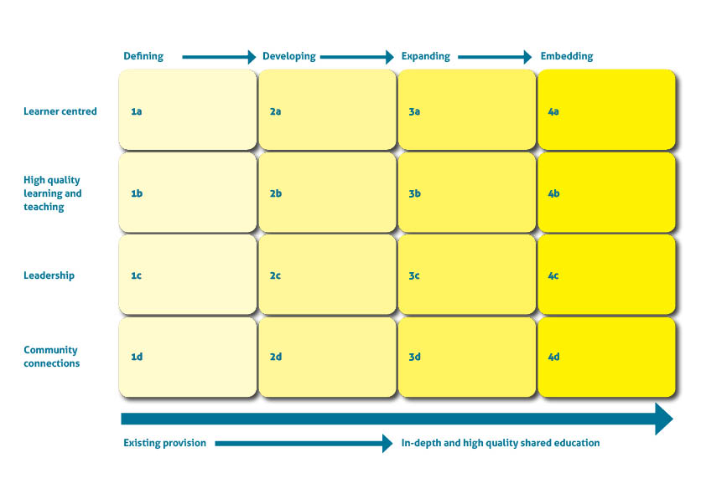

Learner-centred | Defining 1a  Early years settings: | Developing 2a  Early years partnerships: | Expanding 3a  Early years partnerships: | Embedding 4a  Early years partnerships:
Participation in shared education | - seek ways to give children an experience of shared education activities to learn better about themselves and one another | - engage children in sustained shared education activities across the curriculum | - use children’s views to inform the planning and development of a programme of shared education activities | - engage children in a sustained shared education programme to learn better in a planned and progressive way about children from other denominations and cultures
Surmounting barriers  e.g. cognitive, emotional, personal, social and physical | - build capacity to meet the needs of children from a variety of backgrounds, including the newcomer children | - audit, identify and develop strategies and structures to enable children from different backgrounds/denominations to interact, play with one another and respect each other’s culture | - plan collaboratively and use common strategies and structures to enable children to benefit from shared education activities | - develop, monitor and review collaborative working to enable children to learn together effectively
Outcomes  Education and reconciliation | - develop children’s awareness of themselves, their family and others in their local community to explore similarities and difference in order to develop respect for themselves and others. | - develop strategies to improve children’s educational and social outcomes through shared learning | - demonstrate progress in measurable outcomes for example -for children’s behaviour, personal social and emotional development and their use of a shared language | - prepare children better for their next stage of education through improving their skills in understanding reconciliation and diversity

High quality learning and teaching | Defining 1b  Early years settings: | Developing 2b  Early years partnerships: | Expanding 3b  Early years partnerships: | Embedding 4b  Early years partnerships:
Planning for shared education | - develop an awareness of shared education and the benefits it holds for children’s learning about and from one another | - develop and implement a programme of shared education activities based on the Curricular Guidance for Pre-School | - plan shared education strategies throughout the curriculum and across all classrooms | - plan and implement shared education within and beyond the classroom and into the wider community
Quality of learning experiences | - ensure all children are at ease with their and others’ differences through shared learning activities | - plan, develop and implement the curriculum to include enriching shared learning activities | - monitor shared learning activities to motivate children to attain better and improve their understanding and appreciation of difference | - create safe, respectful and high quality shared learning environments which sustain high quality learning
Assessment for, and of, shared education | - develop ways to assess children’s understanding of similarities and, difference, belonging and tolerance of others | - establish a baseline position of children’s understanding of sharing and making new friends , to inform shared learning activities and set curriculum targets | - evaluate progress in children’s understanding of difference and tolerance of others to demonstrate the impact of shared learning activities on the children’s educational outcomes | - establish an agreed shared learning programme to encourage collaborative working across partnering settings and their wider communities and to enrich the children’s transition to primary education

Effective Leadership | Defining 1c  Early years settings: | Developing 2c  Early years partnerships: | Expanding 3c  Early years partnerships: | Embedding 4c  Early years partnerships:
Strategic leadership for shared education:  - SLT  - Governance | - reflect and model more fully a respect for diversity and mutual respect and ensure all policies and procedures meet the requirements of equality legislation | - set a clear vision for shared education by agreeing with governors, staff and parents the benefits of shared education for the children across the settings | - review the shared education programme through governance, curriculum planning, learning and teaching across the settings | - establish collaborative leadership and management of shared education across the settings
Action to promote improvement in shared education | - feature shared education clearly in the setting’s development plans | - identify the extent and quality of shared education to inform the development plans | - jointly evaluate and develop action plans to improve the children’s educational outcomes | - evaluate, refine and implement actions to sustain improved outcomes for children
Empowering and supporting staff in shared education | - identify the training needs and level of expertise of staff on shared education | - secure and implement a joint training programme to develop staffs’ confidence and competence in shared education | - enable staff to access CPD regularly to identify and disseminate effective practice in shared education | - promote and empower collaborative leadership at all levels
Resources/  Accommodation | - reflect on resources and accommodation which can be shared with another setting or required to enable joint working | - share resources and accommodation between settings to ensure efficiency and promote collaborative working | - plan jointly how resources and accommodation can be secured to provide shared learning provision leading to educational improvement | - budget resources and accommodation to establish shared education provision in the long term

Community Connections | Defining 1d  Early years settings: | Developing 2d  Early years partnerships: | Expanding 3d  Early years partnerships: | Embedding 4d  Early years partnerships:
Parents/ Carers | - enable parents/carers to understand and appreciate the educational benefits for their children of shared education | - develop ways to engage parents/carers in planning shared education activities | - inform parents/carers of the outcomes of shared education activities | - engage parents/carers in the review of outcomes of shared education to inform further development
External partners | - promote shared education links within and across other early years settings and their communities and have due regard for adult-child ratios, and risk assessments for visits | - work with external partners to enable shared education practice to develop and flourish in the interests of children and the wider communities | - monitor and evaluate shared education with external partners to demonstrate the positive impact on outcomes for children and their communities | - extend and instil shared education ethos to enrich the shared education dimension of the early years settings and their communities
Community access and engagement | - provide access to the early years setting’s through planned contact, information events and sharing of resources and activities to develop community involvement | - engage with local community groups to develop an understanding of the benefits of shared education | - take account of issues/interests of the local community to inform shared education activities | - enable ongoing community access to early years settings’ resources and activities to promote shared education and community cohesion

Self-evaluation: Mapping our journey to effective shared education
 | Defining | Developing | Expanding | Embedding
Learner-centred
High quality learning and teaching
Leadership
Community connections

Main forms of evidence to support evaluations

Going well (max 3)
1.

2.

3.

Going forward (max 3)
1.

2.

3.

Issues raised by partnership
1.

2.

3.

The report of the Ministerial Advisory Group provides an extremely useful literature review of both international research evidence and local studies.
ETI, A Final Evaluation of the International Fund for Ireland’s Sharing in Education Programme (November, 2013); RSM McClure Watters, Evaluation of the Sharing Education Programme – Programme Level Summative Evaluation Report (May 2014)
early years partnerships should seek to engage in self-evaluation as a partnership at the outset in order to plan collaboratively joint actions to bring about improvement
For example, at developing stage, sustained could mean a minimum of 6 quality shared contact sessions, expanding to a minimum of 12 shared contact sessions and at embedding stage, shared classes are daily/weekly.
Educational outcomes could include skills in communication, using mathematics, ICT, thinking skills and personal capabilities, attitudes and dispositions for learning, behaviours, attendance, punctuality, progress measured through internal data and standards in public examinations/accreditation.

